**CBIO204: Fundamentals of Databases**

**Spring 2025**

**Project Report**

**Under Supervision of: Dr. Muhammad Elsayeh**

**Team Members:**

1. Arwa Sharkawi – 222000121
2. Farida Hany – 222000070

Contents

**1- Conceptual Design 3**

**2- ER Diagram 9**

**3- SQL 10**

**4- User Interface 13**

# **1- Conceptual Design**

Entities and Attributes

**Entity: Research**

* ResearchID (PK) : Simple
* Title
* PublicationDate
* BiomedicalResearchField
* Abstract
* Citations : No of citations (Derived)
* A diagram of a research paper

  AI-generated content may be incorrect.JournalISSN (FK to journal)

**Entity: Author : Multi-valued**

* AuthorID (PK) : Simple
* Name : Composite
* Qualification
* Affiliation
* JobTitle
* Email : Simple
* A diagram of a author

  AI-generated content may be incorrect.HIndex : Simple

**Entity: Journal : Multi-valued**

* ISSN (PK) : Simple
* Name
* BiomedicalResearchFields
* ImpactFactor : Simple
* Quarter
* PublisherID (FK to Publisher))
* Country
* JournalStartDate
* VolumePublicationRate
* A diagram of a journal

  AI-generated content may be incorrect.OpenAccessStatus (Yes/No) : Simple

**Entity: Publisher**

* PublisherID (PK)
* Name : Composite

**Entity: ResearchAuthor**

* ResearchID (PK, FK)
* AuthorID (PK, FK)

**Entity: AuthorField: Multi-valued**

* AuthorID (PK, FK)
* BiomedicalResearchField (PK)

**Entity: PublisherPublicationType : Multi-valued**

* PublisherID (PK, FK)
* PublicationType (PK)

**Entity: PublisherPaymentMethod : Multi-valued**

* PublisherID (PK, FK)
* PaymentMethod (PK) — e.g., cash, bank transfer, online payment

***Relationships:***

**A. Research - Author (Many-to-Many)**

* A Research paper can have multiple Authors.
* An Author can contribute to multiple Research papers.

**B. Research - Journal (One-to-Many)**

* A Research paper is published in exactly one Journal.
* A Journal can publish many Research papers.

**C. Research - BiomedicalField (One-to-Many)**

* A Research paper primarily belongs to one BiomedicalField.
* A BiomedicalField can encompass many Research papers.

**D. Research - Citation (Self-referencing Many-to-Many)**

* A Research paper can cite multiple other Research papers.
* A Research paper can be cited by multiple other Research papers.

**E. Author - BiomedicalField (Many-to-Many)**

* An Author can have interest in multiple BiomedicalFields.
* A BiomedicalField can be of interest to multiple Authors.

**F. Journal - Publisher (Many-to-One)**

* A Journal is published by exactly one Publisher.
* A Publisher can publish many Journals.

**G. Journal - BiomedicalField (Many-to-Many)**

* A Journal can cover multiple BiomedicalFields.
* A BiomedicalField can be covered by multiple Journals.

**H. Publisher - PublicationType (Many-to-Many)**

* A Publisher can handle multiple PublicationTypes.
* A PublicationType can be handled by multiple Publishers.

**I. Publisher - PaymentMethod (Many-to-Many)**

* A Publisher can accept multiple PaymentMethods.
* A PaymentMethod can be accepted by multiple Publishers.

# **2- ER Diagram**

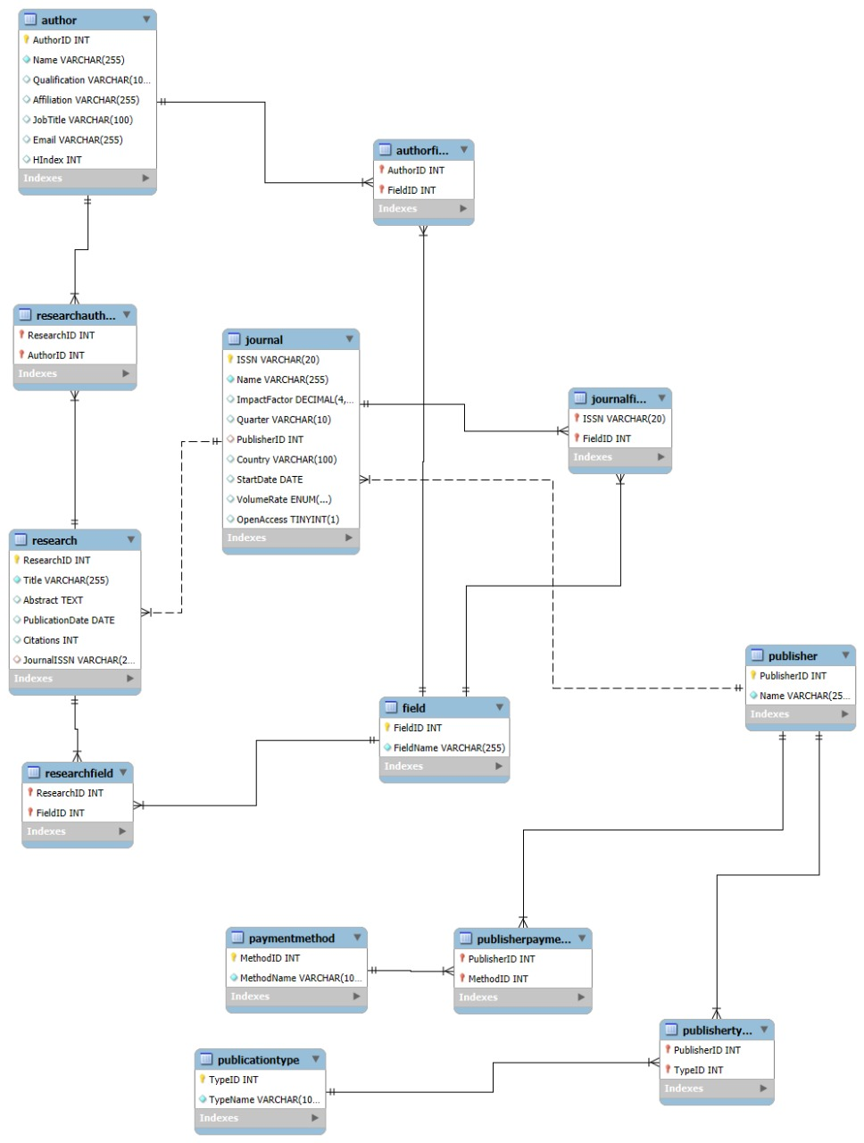

# 3- SQL

* **Data base creation:**
* **A close-up of a white background

  AI-generated content may be incorrect.Table creation**

These statements create the structure of your tables, define columns, data types, primary keys (PK), foreign keys (FK), and constraints.

**As for Example the “publisher table”:**

* **CREATE TABLE Publisher**``: Defines a table to store information about publishers.
* ``**PublisherID INT PRIMARY KEY AUTO_INCREMENT:** This column serves as the unique identifier for each publisher.
* **INT:** Integer data type.
* **PRIMARY KEY**: Ensures that each PublisherID is unique and not null, serving as the main key for identifying publisher records.
* **AUTO_INCREMENT:** Automatically assigns a sequential integer value to PublisherID for each new record inserted, simplifying ID management.
* **``Name VARCHAR(255) NOT NULL**: Stores the name of the publisher.
* **VARCHAR(255):** Variable-length string, allowing up to 255 characters.
* NOT NULL: Ensures that every publisher record must have a name.
* **Data Manipulation**

The **INSERT statements** used to add data to the tables within the LifeScienceDB database. As here we insert 10 distinct **biomedical fields** into the **Biomedical Field table**. Each entry provides a **Field Name** (e.g., 'Genetics and Genomics') and a **brief Description**. This data populates the core categories by which research, authors, and journals can be classified or associated.

* **Database Views**

This view provides a list of authors who are associated with the 'Immunology' biomedical field. It simplifies retrieving specific author details for a particular area of interest.

* A screenshot of a computer

  AI-generated content may be incorrect.**Queries**

SELECT queries are designed to extract specific information from the LifeScienceDB database. As for example, we use a query that identifies and lists the unique names of authors whose research interests include 'Immunology'. It achieves this by joining the Author table with the AuthorField associative table and the BiomedicalField table, allowing it to filter for authors linked to the specific 'Immunology' field.

# 4- User Interface

Figure Log In Screen

Figure User View (top) and Admin View (bottom)